**ABDULLAH**

**GUIDE FOR BEGINNERS**

**https://wiki.seeedstudio.com/reComputer_Industrial_Getting_Started/**

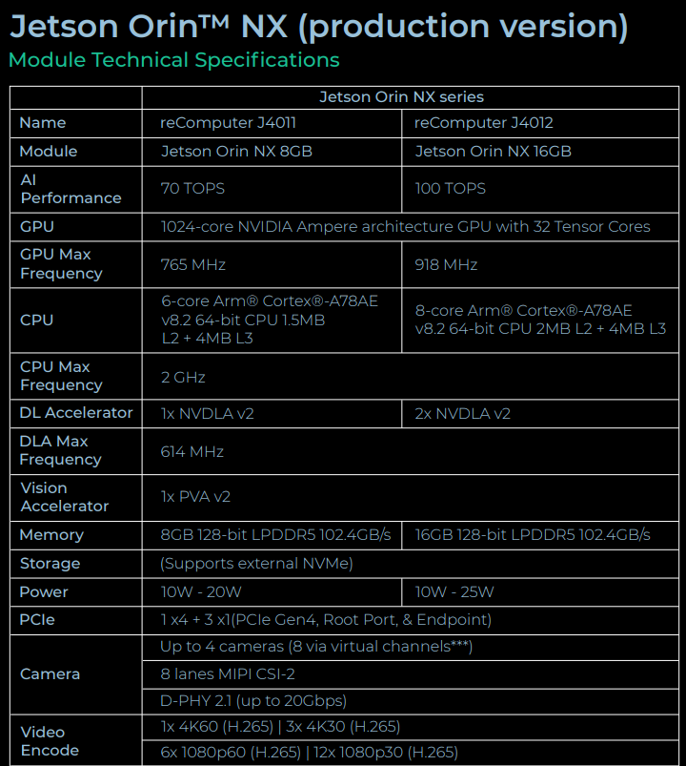

**Power specifications and temperature requirements**

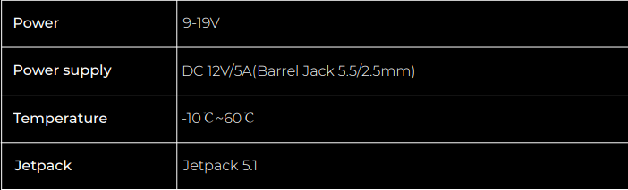

**In particular for object detection**

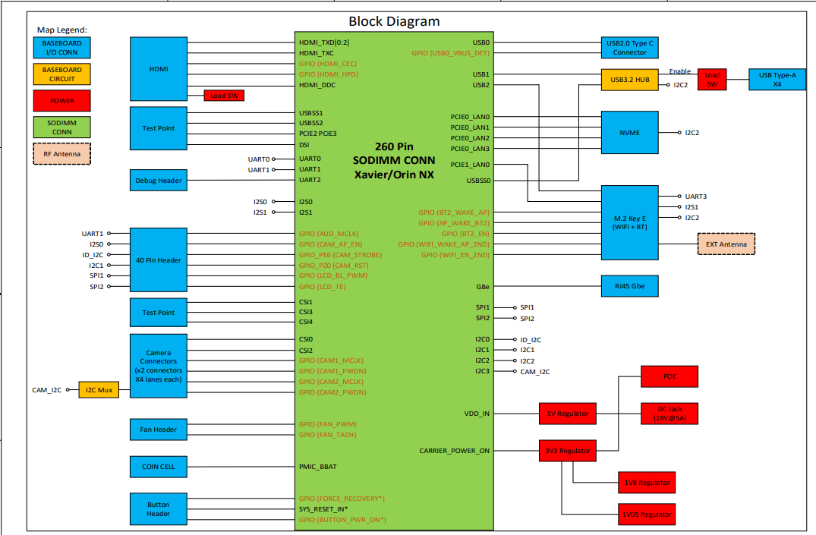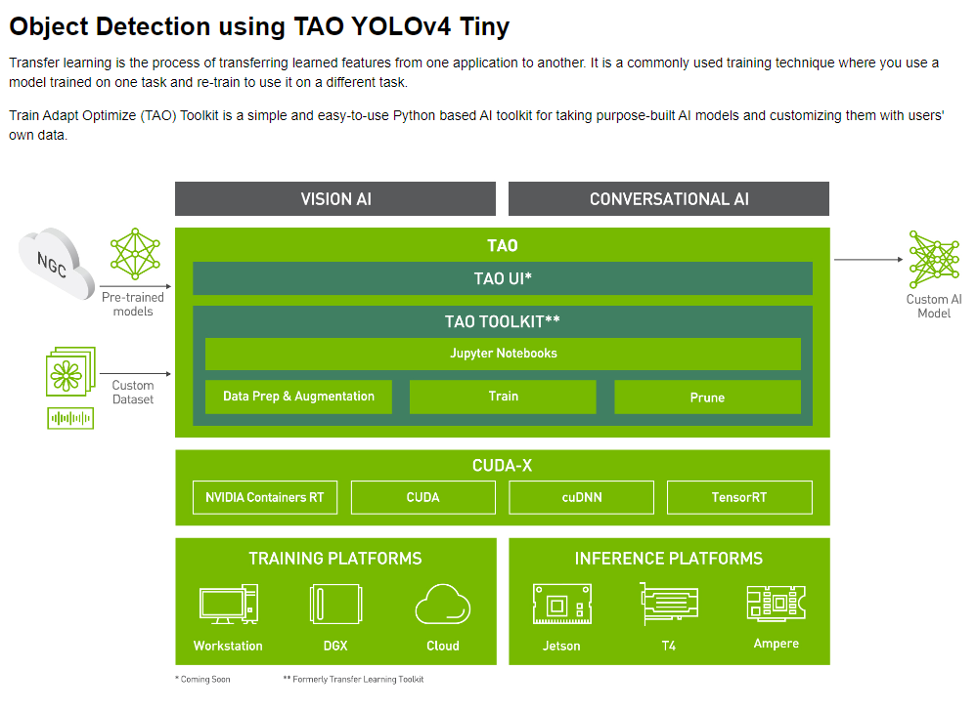

**Install the TAO launcher** [**page**](https://virtualenvwrapper.readthedocs.io/en/latest/install.html) **to set up a python virtual env using the virtualenv and virtualenvwrapper packages. Once you have setup virtualenvwrapper, please set the version of python to be used in the virtual env by using the VIRTUALENVWRAPPER_PYTHON variable. You may do so by runningexport VIRTUALENVWRAPPER_PYTHON=/path/to/bin/python3.x where x >= 6 and <= 8We recommend performing this step first and then launching the notebook from the virtual environment. In addition to installing TAO python package, please make sure of the following software requirements:python >=3.6.9 < 3.8.xdocker-ce > 19.03.5docker-API 1.40nvidia-container-toolkit > 1.3.0-1nvidia-container-runtime > 3.4.0-1nvidia-docker2 > 2.5.0-1nvidia-driver > 455+Once you have installed the pre-requisites, please log in to the docker registry** [**nvcr.io**](http://nvcr.io) **by following the command belowdocker login nvcr.io You will be triggered to enter a username and password. The username is $oauthtoken and the password is the API key generated from ngc.nvidia.com. Please follow the instructions in the** [**NGC setup guide**](https://docs.nvidia.com/ngc/ngc-overview/index.html#generating-api-key) **to generate your own API key.After setting up your virtual environment with the above requirements, install TAO pip package.**

**BLOCK DIAGRAM**

USEFUL LINK

<https://files.seeedstudio.com/wiki/J401/reComputer_J401_SCH_V1.0.pdf>

**Flash JetPack[​](https://wiki.seeedstudio.com/reComputer_J4012_Flash_Jetpack/" \l "flash-jetpack)**

Here, we will show you how to flash [Jetpack](https://developer.nvidia.com/embedded/jetpack) to an NVMe SSD connected to the reComputer J4012/ J4011/ J3010 and J3011. All these devices come with J401 carrier board inside and the flashing procedure is the same for all.

reComputer J40/ J30 series comes with JetPack 5.1 pre-installed on the included NVMe SSD, so that you do not need to flash it. However, if you want to flash it again with JetPack, you can follow this guide.

**Prerequisites**[**​**](https://wiki.seeedstudio.com/reComputer_J4012_Flash_Jetpack/#prerequisites)

* Ubuntu Host PC (native or VM using VMware Workstation Player)
* reComputer J4012/ J4011/ J3010 and J3011
* USB Type-C data transmission cable

**Enter Force Recovery Mode**[**​**](https://wiki.seeedstudio.com/reComputer_J4012_Flash_Jetpack/#enter-force-recovery-mode)

Before we can move on to the installation steps, we need to make sure that the reComputer is in force recovery mode.

**Step 1.** Use a jumper wire to connect the **FC REC** pin and the **GND** pin.

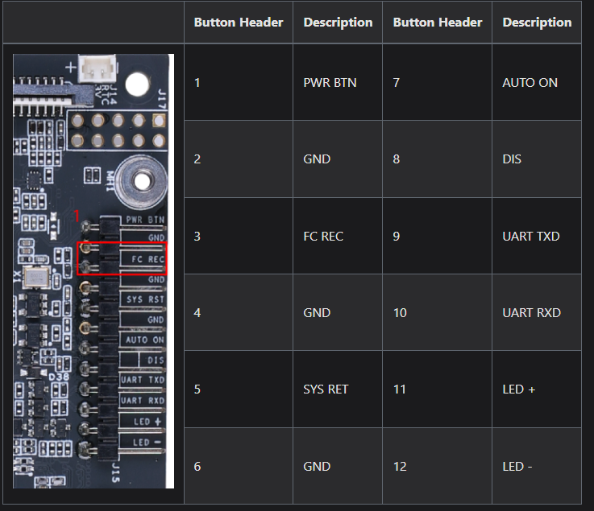

**Step 2.** Power up the reComputer by connecting the included cable from the power adapter and connect the board with the Ubuntu host PC with a USB Type-C data transmission cable

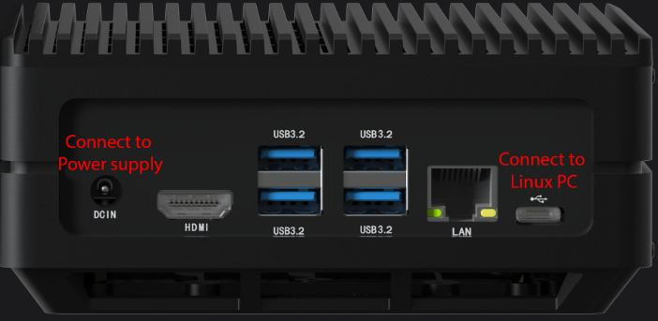

**Step 3.** On the Linux host PC, open a Terminal window and enter the command lsusb. If the returned content has one of the following outputs according to the Jetson SoM you use, then the board is in force recovery mode.

* For Orin NX 16GB: **0955:7323 NVidia Corp**
* For Orin NX 8GB: **0955:7423 NVidia Corp**
* For Orin Nano 8GB: **0955:7523 NVidia Corp**
* For Orin Nano 4GB: **0955:7623 NVidia Corp**

The below image is for Orin NX 16GB

+-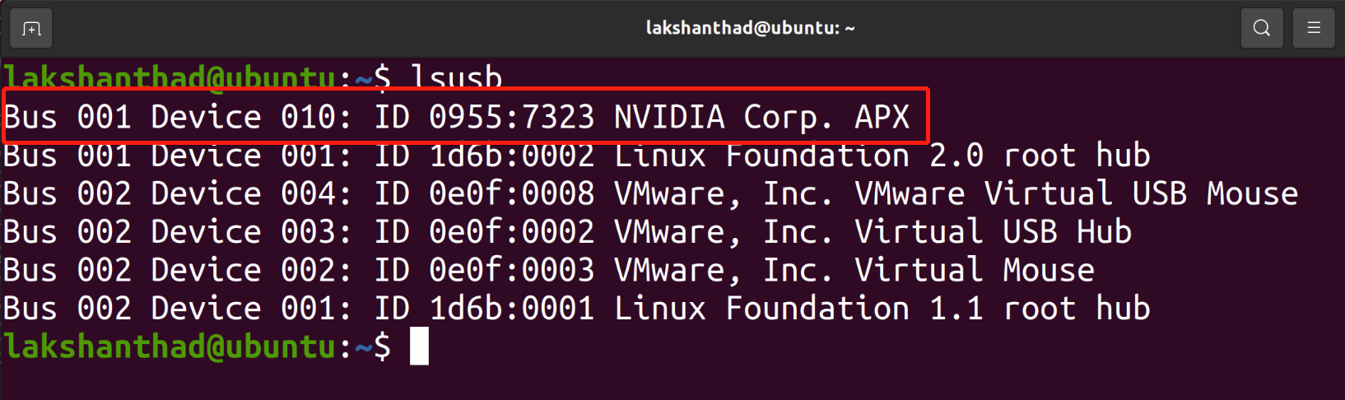

**Step 4.** Remove the jumper wire

**Step 4.** Remove the jumper wire

**Flash to Jetson**[**​**](https://wiki.seeedstudio.com/reComputer_J4012_Flash_Jetpack/#flash-to-jetson)

NOTE

Before moving onto flashing, it should be noted that Jetson Orin NX module only supports JetPack 5.1 and above, while Jetson Orin Nano module only supports JetPack 5.1.1 and above.

* JP5.1.1
* JP5.1.2

Here we will use NVIDIA L4T 35.3.1 to install Jetpack 5.1.1 on the reComputer

**Step 1:** [Download](https://developer.nvidia.com/embedded/jetson-linux-r3531) the NVIDIA drivers on the host PC. The required drivers are shown below:

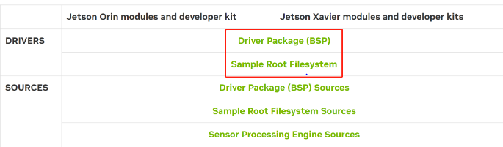

**Step 2:** Extract **Jetson_Linux_R35.3.1_aarch64** and **Tegra_Linux_Sample-Root-Filesystem_R35.3.1_aarch64** by navigating to the folder containing these files, apply the changes and install the necessary prerequisites

tar xf Jetson_Linux_R35.3.1_aarch64

sudo tar xpf Tegra_Linux_Sample-Root-Filesystem_R35.3.1_aarch64 -C Linux_for_Tegra/rootfs/

cd Linux_for_Tegra/

sudo ./apply_binaries.sh

sudo ./tools/l4t_flash_prerequisites.sh

**Step 3:** Configure your username, password & hostname so that you do not need to enter the Ubuntu installation wizard after the device finishes booting

sudo tools/l4t_create_default_user.sh -u {USERNAME} -p {PASSWORD} -a -n {HOSTNAME} --accept-license

For example (username:"nvidia", password:"nvidia", device-name:"nvidia-desktop"):

sudo tools/l4t_create_default_user.sh -u nvidia -p nvidia -a -n nvidia-desktop --accept-license

**Step 4:** Flash the system to the NVMe SSD

sudo ./tools/kernel_flash/l4t_initrd_flash.sh --external-device nvme0n1p1 \

-c tools/kernel_flash/flash_l4t_external.xml -p "-c bootloader/t186ref/cfg/flash_t234_qspi.xml" \

--showlogs --network usb0 p3509-a02+p3767-0000 internal

You will see the following output if the flashing process is successful.

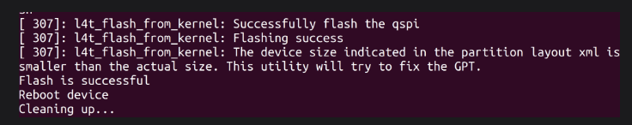

LINK USEFUL FOR DEVELOPERS.

<https://forum.seeedstudio.com/>